**E-libaray face recgonazations management**

***Report submitted to***

***Rajiv Gandhi University of Knowledge Technologies,***

***Srikakulam. for the fulfilment of mini project***

***of***

**Bachelor of Technology**

**in Computer Science and Engineering**

***by***

**L.jyothi(S161206)**

**P.sayamma (S160734)**



**DEPARTMENT OF COMPUTER SCIENCE ENGINEERING**

**RAJIV GANDHI UNIVERSITY OF KNOWLEDGE TECHNOLOGIES, SRIKAKULAM MAY 2021**

© 2021,L.JYOTHI,P.sayamma. All rights reserved.

**RAJIV GANDHI UNIVERSITY OF KNOWLEDGE** **TECHNOLOGIES**

**DEPARTMENT OF COMPUTER SCIENCE ENGINEERING**

**(A.P. Government Act 18 of 2008)**

**RGUKT-Srikakulam, Srikakulam Dist – 532402**

**Declaration**

We certify that

1. The work contained in this report is original and has been done by us under the guidance of my supervisor(s).
2. The work has not been submitted to any other Institute for any degree or diploma.
3. We have followed the guidelines provided by the Institute in preparing the report.
4. We have conformed to the norms and guidelines given in the Ethical Code of Conduct of the Institute.
5. Whenever We have used materials (data, theoretical analysis, figures, and text) from other sources, We have given due credit to them by citing them in the text of the report and giving their details in the references. Further, We have taken permission from the copyright owners of the sources, whenever necessary.

*L.JYOTHI(S161206)*

P.Sayamma(s160734)

**RAJIV GANDHI UNIVERSITY OF KNOWLEDGE** **TECHNOLOGIES**

**DEPARTMENT OF COMPUTER SCIENCE ENGINEERING**

**(A.P. Government Act 18 of 2008)**

**RGUKT-Srikakulam, Srikakulam Dist – 532402**

**Certificate**

This is to certify that the Dissertation Report entitled, “**E-libaray face recognazattion management**” submitted by **Ms.L.JYOTHI, Ms.P.Sayamma** to Rajiv Gandhi university of Knowledge Technologies, Srikakulam, India, is a record of bonafide Project work carried out by him/her under my/our supervision and guidance and is worthy of consideration for the fulfilment of mini-project of Bachelor of Technology in computer Science and Engineering of the Institute.

________________________ _______________________

**Mr.Jayakrishna Examiner**

Project Supervisor Project 0Examiner

Faculty Dept. of CSE Faculty Dept. of CSE

**RGUKT IIIT Srikakulam RGUKT IIIT Srikakulam**

Date:04-06-2021

**ACKNOWLEDGEMENT**

We would like to express our profound gratitude and deep regards to our guide ***Mr.Jayakrishna*** for his exemplary guidance, monitoring and constant encouragement to usthroughout this semester. We shall always cherish the time spent with him during the course of this work due to the invaluable knowledge gained in the field of Web Development.

We are extremely grateful for the confidence bestowed in us and entrusting our project entitled **“E-libaray facerecgonazations managements”.**

We express gratitude to Mr.Ch.Satish Kumar (HOD of CSE) and other faculty members for being source of inspiration and constant encouragement which helped us in completing the project successfully.

Finally, yet importantly, we would like to express our heartfelt thanks to our beloved God and parents for their blessings, our friends for their help and wishes for the successful completion of this project.

L.JYOTHI(S161206)

P.Sayamma(s160734)

**ABSTRACT**

Online Library Management System is a system which maintains the information about the books present in the library, their authors, the members of library to whom books are issued, library staff and all. This is very difficult to organize manually. Maintenance of all this information manually is a very complex task. Owing to the advancement of technology, organization of an Online Library becomes much simple. The Online Library Management has been designed to computerize and automate the operations performed over the information about the members, book issues and returns and all other operations. This computerization of library helps in many instances of its maintenances. It reduces the workload of management as most of the manual work done is reduced.

Here we are adding face recognazations it will helps elimanate to duplicate peoples.easily finds and reduced the database.

**CONTENTS**

|  |  |
| --- | --- |
| Title Page | i |
| Declaration | ii |
| Certificate by Supervisor | iii |
| Acknowledgement | iv |
| Abstract | v |
| Contents | vi |
| Chapter 1 Introduction  1.1 Problem Statement  1.2 Motivation of the Project  1.3 Limitations of the Project  1.4 Existing System  1.5 Proposed System | 1  1  1  1  2  2 |
|  |  |
| Chapter 2 Implementation  2.1 Implementation of Front-end:  2.2 Implementation of Back-end:  2.3 Use of Modern tool /Technology | 5  6  6  7 |
| Chapter 3 Requirement Specification  3.1 System Requirements  3.2 Hardware Requirements  3.3 Software Requirements | 8  11 |
|  |  |
| Chapter 4 System Design  4.1 Introduction  4.2 Sequence Diagram | 15  15  16 |
| Chapter 5 Results | 18 |
| Chapter 6 Testing and Validation  6.1 Introduction  6.2 Types of Testing  6.2.1 Unit Testing  6.2.2 Integration Testing  6.3 Validation | 24  24  25  25  25  25 |
| Chapter 7 Conclusion | 26 |
| References | 27 |
| Appendix | 28 |

1. **INTRODUCTION**

In this competitive world, there is a need to showcase the abilities of people’s oral communication skills as the real success of their talent depends on how they present their speaking skills and how they convince the others in persuading them.Even if there are four other skills in the English language, speaking skills are the most effective one among them as a majority of communication is done through speech.

People are increasingly using websites/applications in order to enhance their speaking skills. We design a meet application which is is helpful for the people to strengthen their communication skills.The scope of the web application is, in order to join any of the meets we need to know the meet link of that particular meeting. But, In this web application there is no need of knowing the meet link before joining.This web application can be established the communication between the people of an organization.

**1.1 Problem Statement**

During this pandemic, it’s impossible to conduct face-face communications for the students to enhance their speaking skills.To make it possible, we need a flexible virtual meet application in which people can communicate with each other and share their knowledge to get ready for the jobs.Based on their free time one can access and connect to any other person to improve his/her communication skills.

**1.2 Motivation of the Project**

Designing a meet application which is helpful to conduct communication skills laboratory.

**1.3 Limitations of the Project**

Not having a flexible virtual meet application for our english department to conduct english communication skills laboratory during this pandemic.

**1.4 Existing System**

Current models are not flexible enough to conduct group discussions, debates etc.

That is because…

* All the participants should know the meet link before joining
* Random way of connecting people and joining is not possible (as both parties need a common link to join)

**1.5 Proposed System**

The proposed method can generate synthetic images by transferring different styles of some images to another given content images without any losses of content. The final transferred image can maintain most of the salient region information consistent with that of content image.

1. **IMPLEMENTATION**

For instance after open the website user may login into the system by using login page .A login page is a web page to a website that requires user identification and authentication, regularly performed by entering a username and password combination.when the user login into the website if the user don't have an account yet there we provided the option called sign up.

Sign up page is created for the registration process,using this page the user may enter him/her details and then create an account in the website.All the user entered details are stored in the database to match the login credentials with the user created username and password.

When the user logins,the website sends the data to the backend server where it validates from a database whether the username and password matches,if it does it redirects the

user to the home page.

After visiting the homepage, there we provided activity section.That section will have different activities like group discussion ,debate and JAM in order to participate in it and to enlarge the speaking skills of an individuals.

For instance,user may join in the group discussion activity by clicking on the join now option provided under the group discussion element that will redirect the user to the meeting in that we restricted the team size to 4 people,for the debate team members are 4 people but the team size is 2 people and for the JAM team size is 4 people.

In the home page itself, we provided guidelines regarding the activities for the user understanding purpose. The user may observe the details about the tasks there.

Before using the website the users may have many queries regarding the website.Therefore in the FAQ section, all the required queries are well explained.

**Implementation has to be done in 2 parts:**

1. Front end Development (HTML,CSS,JS,BOOTSTRAP)

2.BackendDevelopment(PHP,MYSQL,XAMPPLOCALSERVER, Flask,

Visual studio,face recognazations)

**3.1 Implementation of Front-end:**

1. Front end Development (HTML,CSS,JS,BOOTSTRAP)

**Tasks:**

**User Registration page:** If the user new to our website they have to register using this page

**User Login Page :** Inorder to access our home page they need to login to this page.

**Home page :** The main functionality of our website will be done in this page.

**Contact Us page :**If they have any queries they just use this page

**Guidelines page :**If they want any guidelines from us they just use this page.

**About page :**Tells about developers

**User Logout page :**After completion of their work they just use.

**Styles page :**CSS related code will be there.

HTML,CSS,JavaScript and Bootstrap are the Web technologies used for designing the Front end of our website. To design the web pages we used the technology called bootstrap.For convenience we used bootstrap technology to get better webpages and better performance of website.

**3.2 Implementation of Back-end:**

2. Back end Development (PHP,MYSQL,XAMPP LOCAL SERVER,Flask,

face recognazations)

**Tasks:**

**XAMPP Local server configuration:** Inorder to develop back end of project we used XAMPP Sever .

**User Registration page :**If the new user enter their details into our website thise details are saved in the database using this page.

**User Login validation page :**If the user are already registered into our website ,we will just give the validation to access our website.

**Clicks_reading & Redirecting page :**The main functionality of our website will be done

Inorder to develop back end of project we used XAMPP Sever .

**USER REGISTRATION (Register.php)**

Tasks:

Step 1: Connecting to the database (to store the entered details)

Step 2:Taking the user entered details (w.t.h “name” attribute)

**STEP 1:**

$host="localhost:7882";

$user="root";

$password="jyothi123";

$db="usersystem";

$con=mysqli_connect($host,$user,$password,$db);

if($con === false)

{

die("connection error".mysqli_connect_error($con));

}

**Step2:**

if(isset($_POST['register']))

{

$name=$_POST['name'];

$username=$_POST['uname'];

$email=$_POST['mail'];

$mobileno=$_POST['mobile'];

$password1=$_POST['pass'];

$data="insert into registrations(name,username,email,mobile,password) values('$name','$username','$email','$mobileno','$password1')";

if($con->query($data))

{

//print "sent successfully";

header("location:Log_In.php");

}

else{

print "something went wrong";

}

}

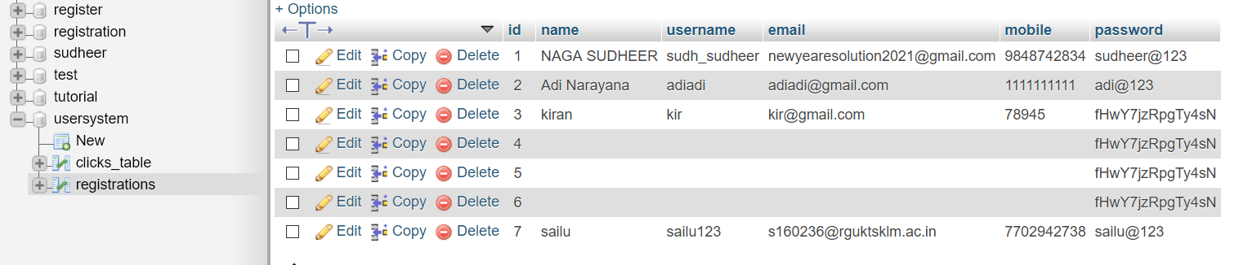

**User Login Validation(Log_In.php)**

STEP 1:Taking the user entered details

STEP 2: Comparing them with the database details

**STEP 1:**

$username=$_POST['uname'];

$password1=$_POST['pass'];

**STEP 2:**

$sql="Select * from registrations where username='".$username."' AND password='".$password1."'";

$result=mysqli_query($con,$sql);

$row=mysqli_fetch_array($result);

if($row)

{

//echo "correct";

$_SESSION['uname']=$username;

header("location:Home_page.php");

}

else{

echo "username or password incorrect";

}



**Redirecting page(click_button.php)**

Step 1:Reading no of clicks and updating

Step 2:Applying logic to get the team

Step 3: Redirecting the current user to the respective team

**STEP 1:**

$User_click=$_POST['click'];

$data="Select No_of_clicks from clicks_table";

$result=mysqli_query($con,$data);

$row = $result->fetch_assoc();

$take_clicks=(int)$row['No_of_clicks'];

$sendd=$take_clicks+1;

//echo $a;

$updating="UPDATE `clicks_table` SET `No_of_clicks` = '$sendd' WHERE `id` = '1'";

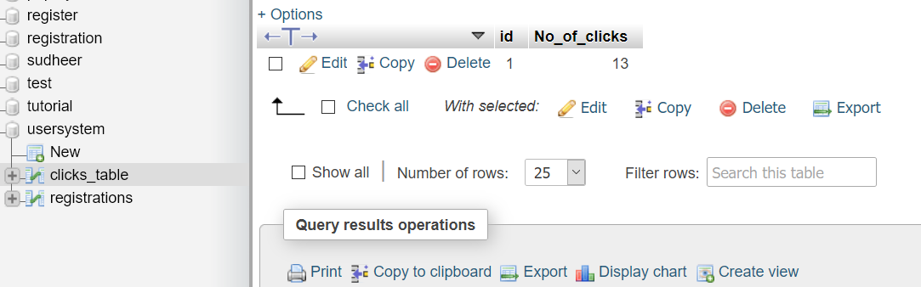

STEP 2:

Count = 1

F = Count/4 ; (0.25)

grp= ceil (F); (1)

Team= grp; (team 1)

Count = 2;

F = Count/4 ; (0.5)

grp= ceil (F); (1)

Team= grp; (team 1)

Count = 3;

F = Count/4 ; (0.75)

grp= ceil (F); (1)

Team= grp; (team 1)

Count = 4;

F = Count/4 ; (1)

grp= ceil (F); (1)

Team= grp; (team 1)

Count = 5;

F = Count/4 ; (1.25)

grp= ceil (F); (2)

Team= grp; (team 2)

Count = 6;

F = Count/4 ; (1.5)

grp= ceil (F); (2)

Team= grp; (team 2)

Count = 15;

F = Count/4 ; (3.75)

grp= ceil (F); (4)

Team= grp; (team 4)

Count = 30;

F = Count/4 ; (7.5)

grp= ceil (F); (8)

Team= grp; (team 8)

Count = 100;

F = Count/4 ; (25)

grp= ceil (F); (25)

Team= grp; (team 25)

**STEP 3:**

if($con->query($updating))

{

//print "sent successfully";

$rounding=ceil($take_clicks/4);

$link="https://meet.google.com/lookup/team".$rounding;

header("location:$link");

}

else{

print "something went wrong";

}

**Use of Modern tool /Technology**

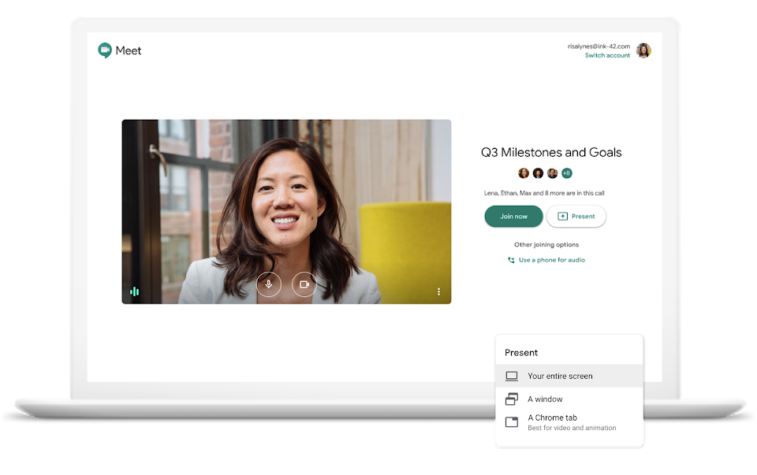



**4. REQUIREMENT SPECIFICATION**

Requirements-Determination is the process, by which analyst gains the knowledge of the organization and apply it in selecting the right technology for a particular application. A Software Requirements Specification (SRS) is a complete description of the behaviour of the system to be developed. It includes a set of use cases that describe all the interactions the users will have with the software. Use cases are also known as functional requirements. In addition to use cases, the SRS also contains non-functional requirements. Non-functional requirements are requirements which impose constraints on the design or implementation (such as quality standards).

**4.3 System Requirements**

To be used efficiently, all computer software needs certain hardware components or other software resources to be present on a computer. These prerequisites are known as (computer) system requirements and are often used as a guideline as opposed to an absolute rule. Industry analysts suggest that this trend plays16 a bigger part in driving upgrades to existing computer systems than technological advancements.

**4.3.1 Hardware Requirements**

The most common set of requirements defined by any operating system or software application is the physical computer resources, also known as hardware, a hardware requirements list is often accompanied by a hardware compatibility list (HCL), especially in case of operating systems. An HCL lists tested, compatible, and sometimes incompatible hardware devices for a particular operating system or application. The following sub-sections discuss the various aspects of hardware requirements.

**Hardware Requirements for Present Project**

1. Processor: Intel Core I3 above
2. RAM: 4GB
3. Storage: 20GB
4. Monitor with 1024*720 resolution

**4.3.2 Software Requirements**

Software Requirements deal with defining software resource requirements and pre-requisites that need to be installed on a computer to provide optimal functioning of an application. These requirements or pre-requisites are generally not included in the software installation package and need to be installed separately before the software is installed.

**Software Requirements for Present Project**

1. Operating System: Windows family/unix
2. Languages: HTML with Bootstrap, JvaScript, php
3. Database: MYSQL XAMPP
4. Tools: Google meet
5. Browsers: All browsers

**6. SYSTEM DESIGN**

**6.1 Introduction**

Grady Booch, James Raumbaugh and Ivar Jacobson have collaborated to combine the best features of their individual object oriented analysis and design methods into a unified method the unified modeling language, the version 1.0 for the Unified Modeling was released in January 1997 the main parts of UML are based on the Booch, OMT and OOSE methods. The goals of UML are:

1. To model systems using object-oriented concepts
2. To establish an explicit coupling between conceptual as well as executable
3. To address the issues of scale inherent in complex, mission critical system
4. To create a modeling language usable by both humans and machines

**Basic Building Blocks of UML**

The basic building blocks in UML are things and relationships; these are combined in different ways following different rules to create different types of diagrams. In UML there are nine types of diagrams, below is a list and brief description of them. The more in depth descriptions in the document, will focus on the first five diagrams in the list, which can be seen as the most general, sometimes also referred to as the UML core diagrams.

**Use case Diagram:** shows a set of use cases, and how actors can use them.

**Class Diagram:** describes the structure of the system, divided in classes with different connections and relationships

**Sequence Diagram:** shows the interaction between a set of objects, through the messages that may be dispatched between them.

**State chart Diagram:** state machines, consisting of states, transitions, events and activities.

**Activity Diagram:** shows the flow through a program from a defined start point to an end point.

**Object Diagram:** A set of objects and their relationships, this is a snapshot of instances of the things found in the class objects.

**Collaboration Diagram:** Collaboration diagram emphasize structural ordering of objects that send and receive messages.

**Component Diagram:** shows organizations and dependencies among a set of components. These diagrams address the static implementation view of the system.

**Deployment Diagram:** show the configuration of run-time processing nodes and components that live on them.

**6.2 Sequence Diagram**

A Sequence diagram is an interaction diagram that shows how processes operate with one another and what is their order. A sequence diagram shows object interactions arranged in time sequence. It depicts the objects and classes involved in the scenario and the sequence of messages exchanged between the objects needed to carry out the functionality of the scenario. A sequence diagram shows, as parallel vertical lines (lifelines), different processes or objects that live simultaneously, and, as horizontal arrows, the messages exchanged between them, in the order in which they occur. The purpose of sequence diagram is to show the flow of functionality through a use case. In other words, we call it a mapping process in terms of data transfers from the actor through the corresponding objects. The key points are:

1. The main purpose is to represent the logical flow of data with respect to a process
2. A sequence diagram displays the objects and not the classes. Messages are written with horizontal arrows with the message name written above them, display interaction. Solid arrow heads represent synchronous calls, open arrow heads represent asynchronous messages, and dashed lines represent reply messages.

When an object destroyed (removed from memory), an X is drawn on top of the lifeline, and the dashed line ceases to be drawn below it (this is not the case in the first example though). It should be the result of a message, either from the object itself, or another.

**Sequence Diagram**

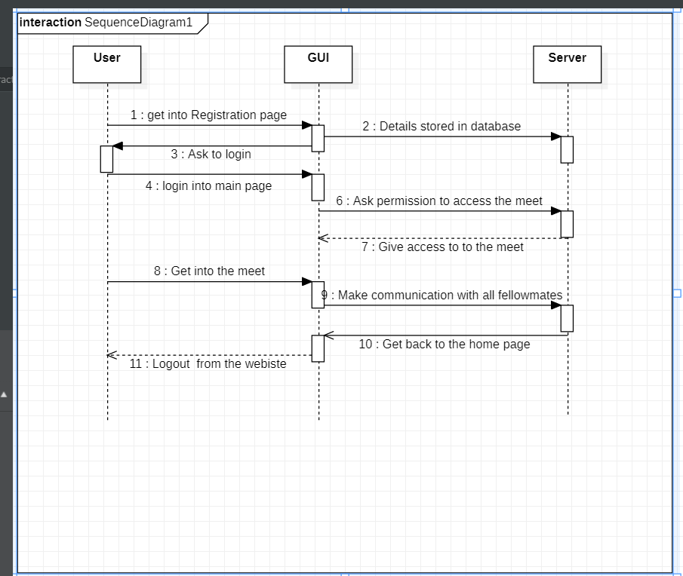

Fig 6.1: Sequence Diagram

**7. RESULTS**

**There are many pages to develop our website.**

**Input Images**

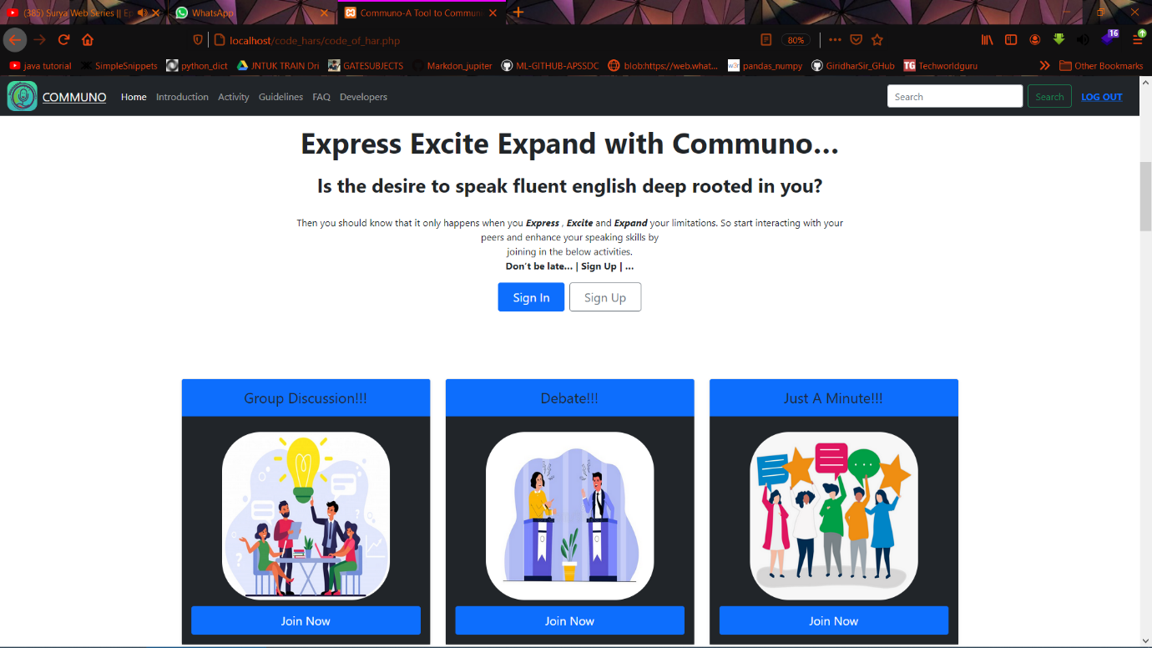

Fig 7.1: Home page

The main functionality of our website will be done in this page.

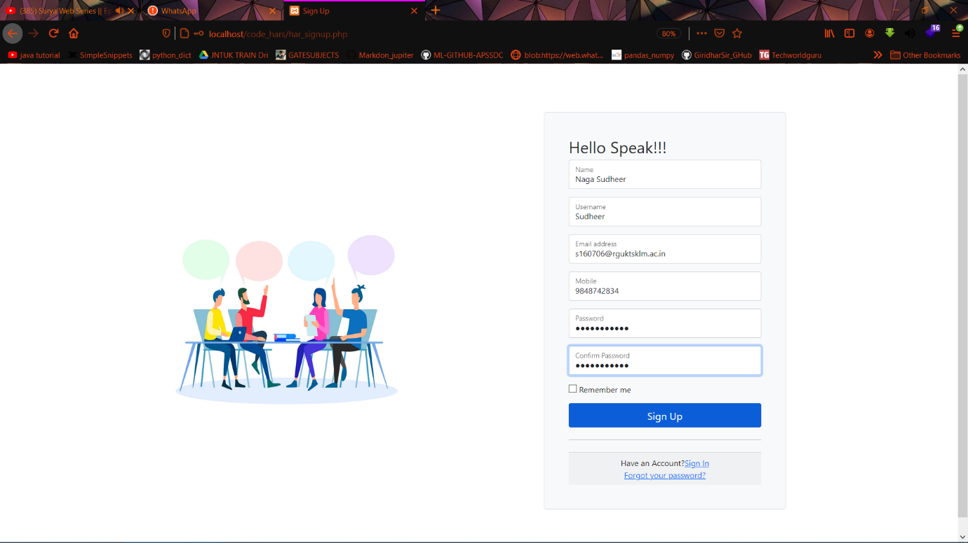

Fig 7.2: Registration page

If the user new to our website they have to register using this page

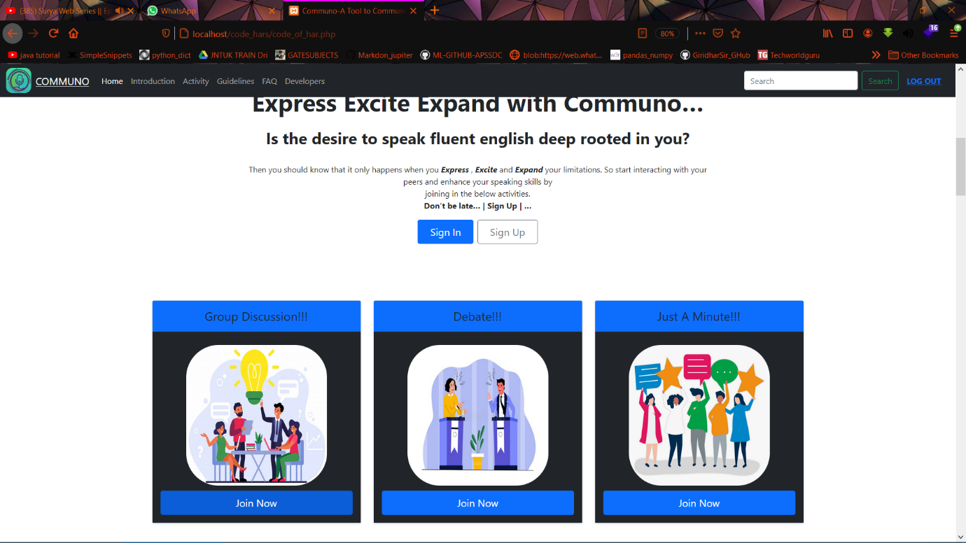

Fig 7.3: Main Functionality

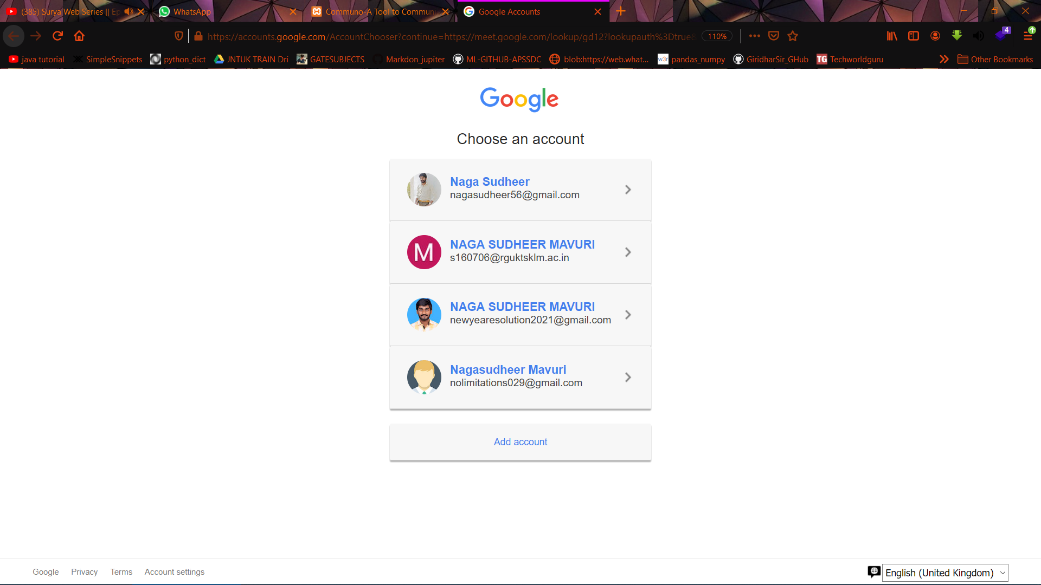

Fig 7.4: Login page

Inorder to access our home page they need to login to this page.

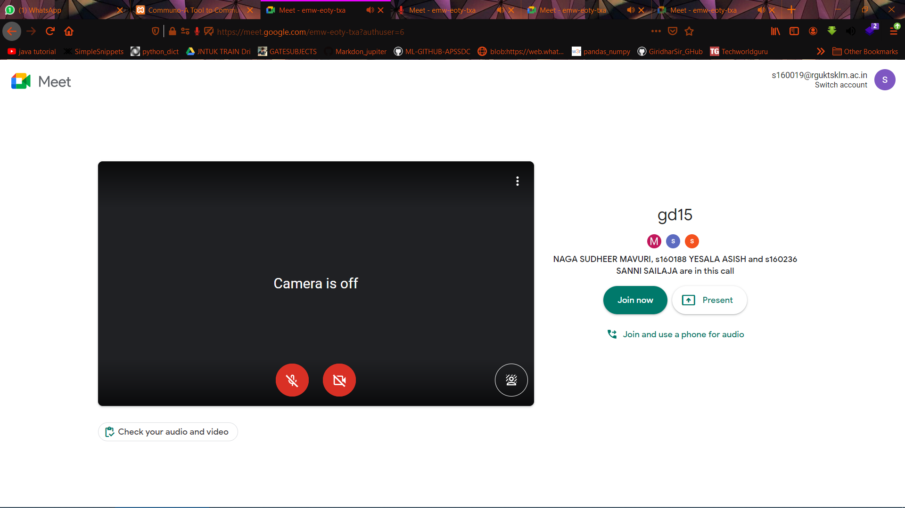

Fig 7.5: Meet Page

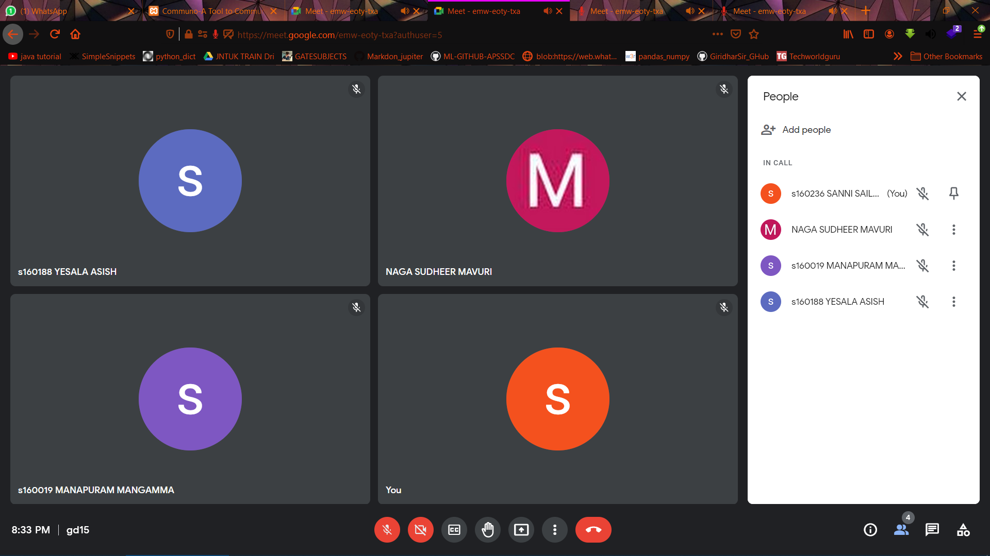

Fig 7.6: Communication page

**8. TESTING AND VALIDATION**

**8.1 Introduction**

Software testing is an investigation conducted to provide stakeholders with information about the quality of the product or service under test. Software testing also provides an objective, independent view of the software to allow the business to appreciate and understand the risks at implementation of the software. Test techniques include, but are not limited to, the process of executing a program or application with the intent of finding software bugs. Software testing can also be stated as the process of validating and verifying that a software program/application/product meets the business and technical requirements that guided its design and development, Works as expected and can be implemented with the same characteristics. Software testing, depending on the testing method employed, can be implemented at any time in the development process. However, most of the test effort occurs after the requirements have been defined and the coding process has been completed. As such, the methodology of the test is governed by the software development methodology adopted.

Different software development models will focus the test effort at different points in the development process. Newer development models, such as Agile, often employ test driven development and place an increased portion of the testing in the hands of the developer, before it reaches a formal team of testers. In a more traditional model, most of the test execution occurs after the requirements have been defined and the coding process has been completed. Testing can never completely identify all the defects within software. Instead, it furnishes a criticism or comparison that compares the state and behaviour of the product against oracles principles or mechanisms by which someone might recognize a problem. These oracles may include (but are not limited to) specifications, contracts, comparable products, past versions of the same product, inferences about intended or expected purpose, user or customer expectations, relevant standards, applicable laws, or other criteria.

**8.2 Types of Testing**

**8.2.1 Unit Testing**

Unit Testing is done on individual modules as they are completed and become executable. It is confined only to the designer's requirements.

**8.2.2 Integration Testing**

Integration testing ensures that software and subsystems work together as a whole. It tests the interface of all the modules to make sure that the modules behave properly when integrated together.

**8.3 Validation**

The system has been tested and implemented successfully and thus ensured that all the requirements as listed in the software requirements specification are completely fulfilled. In case of erroneous input corresponding error messages are displayed.

Table 1: Validation Reports

|  |  |  |  |  |
| --- | --- | --- | --- | --- |
| **Test No.** | **Test Case** | **Expected Output** | **Actual Output** | **Result** |
| **1** | Home page:Accessing meet from the website | Redirected using meet | Redirected using meet | Passed |
| **2** | Calculating Accuracy | Total Accuracy Calculated | Total Accuracy Calculated | Passed |

**9. Conclusion**

* We are creating a web application in which one can join and talk to his/her peers without being bothered about the meeting credentials.
* Able to communicate with anyone from the organization by making this web app live in the server.

**References**

[1] “Image Neural Style Transfer with Preserving the salient regions” Wujian Ye Retrieved 2019 IEEE Access.

[2] "Image Analogies" (PDF). Mrl.nyu.edu. 2001. Retrieved 13 February 2019.

[3] "Image Quilting". graphics.cs.cmu.edu. 2001. Retrieved 4 February 2021.

[4] Gatys, Leon A.; Ecker, Alexander S.; Bethge, Matthias (26 August 2015). "A Neural Algorithm of Artistic Style".

[5] "Very Deep CNNS for Large-Scale Visual Recognition". Robots.ox.ac.uk. 2014. Retrieved 13 February 2019.

[6] Dumoulin, Vincent; Shlens, Jonathon S.; Kudlur, Manjunath (9 February 2017). "A Learned Representation for Artistic Style".

[7] Ruder, Manuel; Dosovitskiy, Alexey; Brox, Thomas (2016). "Artistic Style Transfer for Videos".

[8] Johnson, Justin; Alahi, Alexandre; Li, Fei-Fei (2016). "Perceptual Losses for Real-Time Style Transfer and Super-Resolution".

[9] Chen, Dongdong; Liao, Jing; Yuan, Lu; Yu, Nenghai; Hua, Gang (2017). "Coherent Online Video Style Transfer".

[10] Li, Yijun; Fang, Chen; Yang, Jimei; Wang, Zhaowen; Lu, Xin; Yang, Ming-Hsuan (2017). "Universal Style Transfer via Feature Transforms".

**Appendix**

The proposed method can generate synthetic images by transferring different styles of some images to another given content images without any losses of content. The final transferred image can maintain most of the salient region information consistent with that of content image.

**Source Code**

import torch

import torch.optim as optim

from torchvision import datasets, transforms, models

from PIL import Image

import matplotlib.pyplot as plt

from google.colab import drive

import numpy as np

%matplotlib inline

def load_image(img_path, max_size = 400):

  image = Image.open(data_dir+img_path).convert("RGB")

  if max(image.size) > max_size:

    size = max_size

  else:

    size = max(image.size)

  in_transforms = transforms.Compose([

                          transforms.Resize(size),

                          transforms.ToTensor(),

                          transforms.Normalize((0.485, 0.456, 0.406),

                                  (0.229, 0.224, 0.225))

                                      ])

  image = in_transforms(image).unsqueeze(0)

  return image

def im_convert(tensor):

  image = tensor.to("cpu").clone().detach()

  image = image.numpy().squeeze()

  image = image.transpose(1,2,0)

  image = image * np.array((0.229, 0.224, 0.225)) + np.array((0.485, 0.456, 0.406))

  image = image.clip(0, 1)

  return image

def get_features(image, model):

  layers = {

      '0': 'conv1_1',

      '5': 'conv2_1',

      '10': 'conv3_1',

      '19': 'conv4_1',

      '21': 'conv4_2',

      '28': 'conv5_1'

  }

  features = {}

  x = image

  for name,layer in model._modules.items():

    x = layer(x)

    if name in layers:

      features[layers[name]] = x

  return features

  # for f in features.keys():

  #   print(features[f].shape)

def gram_matrix(tensor):

  _, d, h, w = tensor.size()

  tensor = tensor.view(d, h*w)

  gram = torch.mm(tensor, tensor.T)

  return gram

vgg = models.vgg19(pretrained=True).features

for param in vgg.parameters():

  param.requires_grad = False

device = "cuda" if torch.cuda.is_available() else "cpu"

vgg.to(device)

print(device)

drive.mount("/content/gdrive", force_remount=True)

data_dir = "/content/gdrive/My Drive/Colab Notebooks"

!ls "/content/gdrive/My Drive/Colab Notebooks"

content = load_image("/content.png").to(device)

style = load_image("/style.png").to(device)

fig, (ax1, ax2) = plt.subplots(1, 2, figsize=(20, 10))

ax1.imshow(im_convert(content))

ax2.imshow(im_convert(style))

content_features = get_features(content, vgg)

style_features = get_features(style, vgg)

style_grams = {layer:gram_matrix(style_features[layer]) for layer in style_features}

target = content.clone().requires_grad_(True).to(device)

style_weights = {'conv1_1': 1.,

                 'conv2_1': 0.75,

                 'conv3_1': 0.2,

                 'conv4_1': 0.2,

                 'conv5_1': 0.2}

content_weight = 1  # alpha

style_weight = 1e6  # beta

optimizer = optim.Adam([target], lr = 0.003)

steps = 3200

show_every = 400

for ii in range(1, steps+1):

  target_features = get_features(target, vgg)

  content_loss = torch.mean((target_features['conv4_2'] - content_features['conv4_2'])**2)

  style_loss = 0

    # then add to it for each layer's gram matrix loss

  for layer in style_weights:

      # get the "target" style representation for the layer

      target_feature = target_features[layer]

      target_gram = gram_matrix(target_feature)

      _, d, h, w = target_feature.shape

      # get the "style" style representation

      style_gram = style_grams[layer]

      # the style loss for one layer, weighted appropriately

      layer_style_loss = style_weights[layer] * torch.mean((target_gram - style_gram)**2)

      # add to the style loss

      style_loss += layer_style_loss / (d * h * w)

  # calculate the *total* loss

  total_loss = content_weight * content_loss + style_weight * style_loss

  # update your target image

  optimizer.zero_grad()

  total_loss.backward()

  optimizer.step()

  # display intermediate images and print the loss

  if  ii % show_every == 0:

      print('Total loss: ', total_loss.item())

      plt.imshow(im_convert(target))

      plt.show()

fig, (ax1, ax2, ax3) = plt.subplots(1, 3, figsize=(20, 10))

ax1.imshow(im_convert(content))

ax2.imshow(im_convert(target))

ax3.imshow(im_convert(style))